Steps For Creating Channels Through USTREAM
ANNEXTURE-1

- Enter URL ustream .tv 2. Click Log in
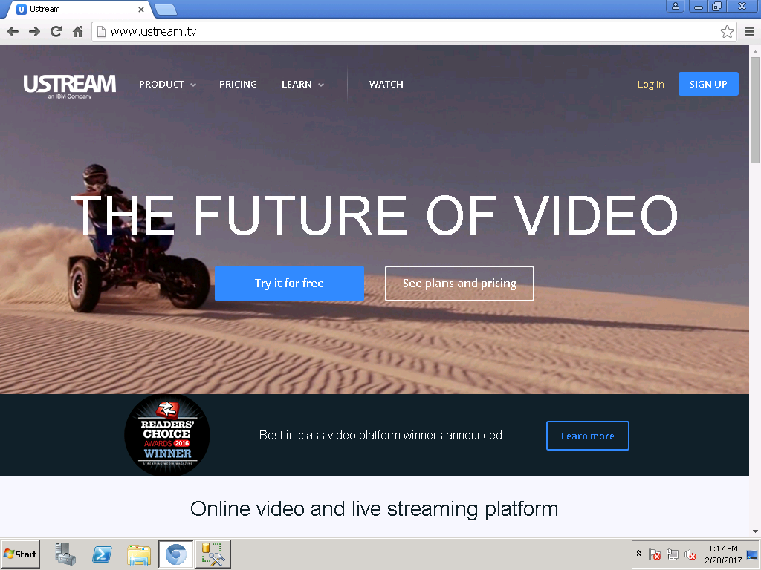
3. Following Window will appear
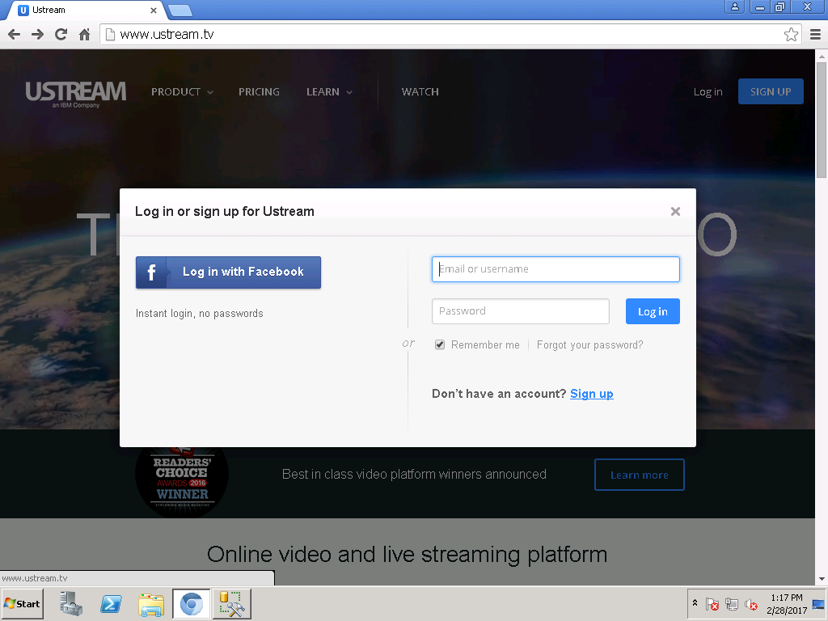
4. Click Sign up (For New User)

5. Following Window will appear
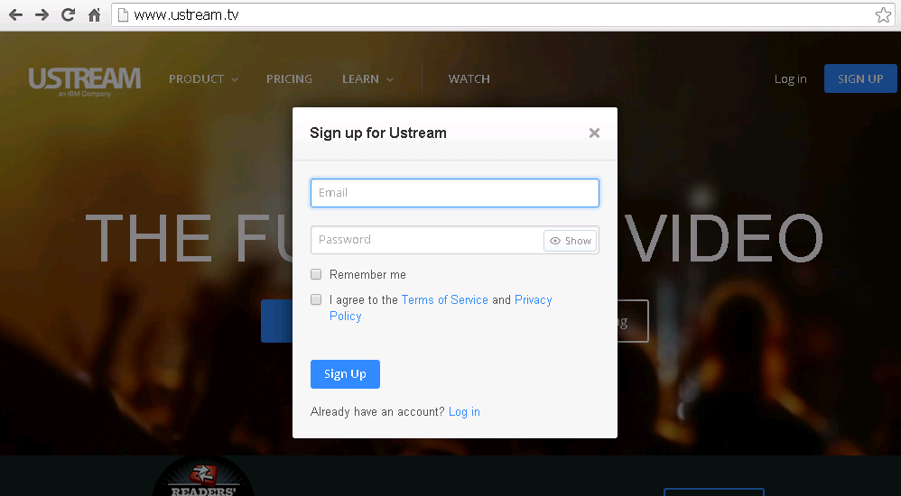
(a) Enter Email ID
(b) Enter Password (Please Enter
Password Required for Ustream)
(c) Check Terms of Service and Privacy Policy
(d) Click Sign Up

6. After Successful Completion of the above steps one can become a ustream user.
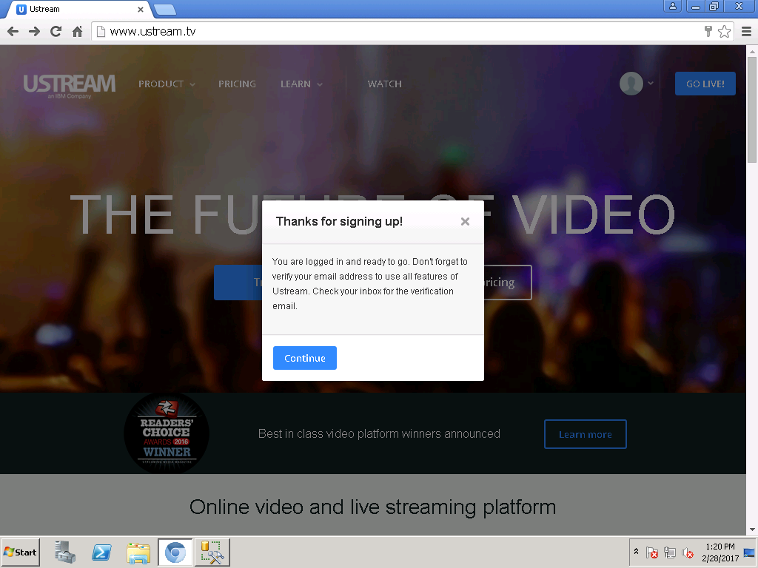
7. Click on Continue Button

8. After Login Click this Logo
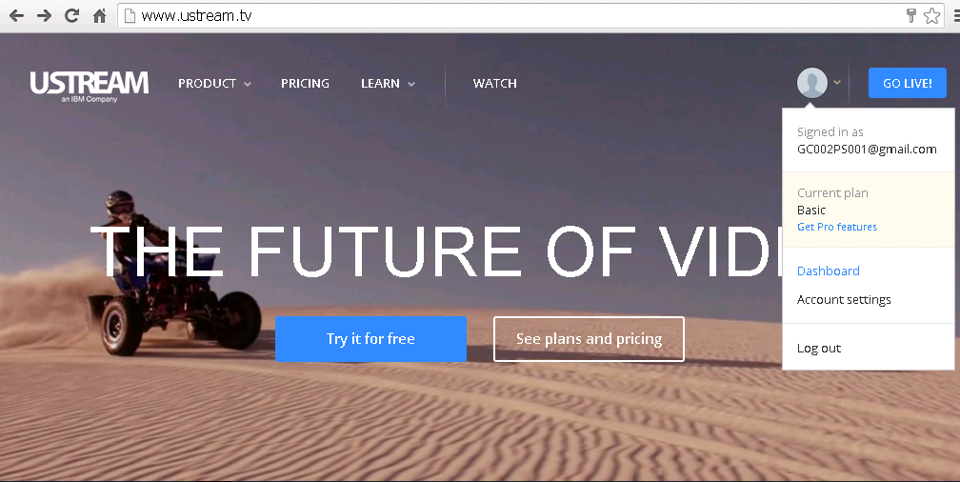
9. Click on Dashboard
10. Click on Create a Channel
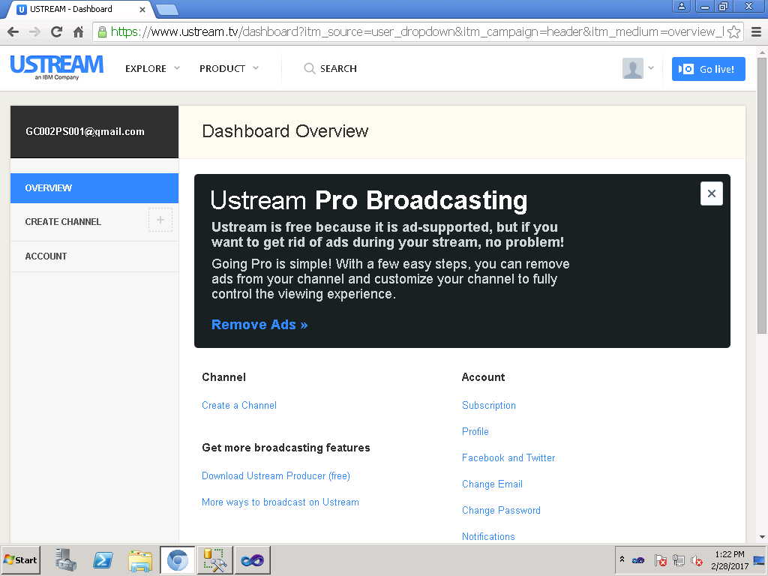

11. Please Enter Name of The Channel
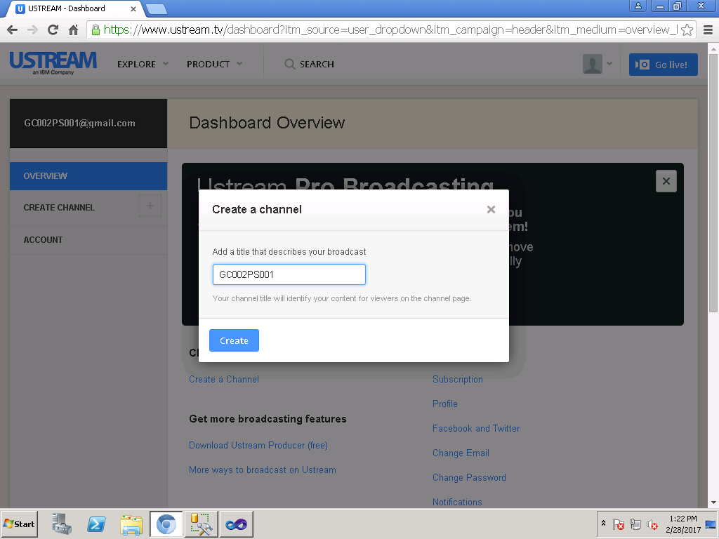
12. Click on Create
13. Select 24/7 in Category Option
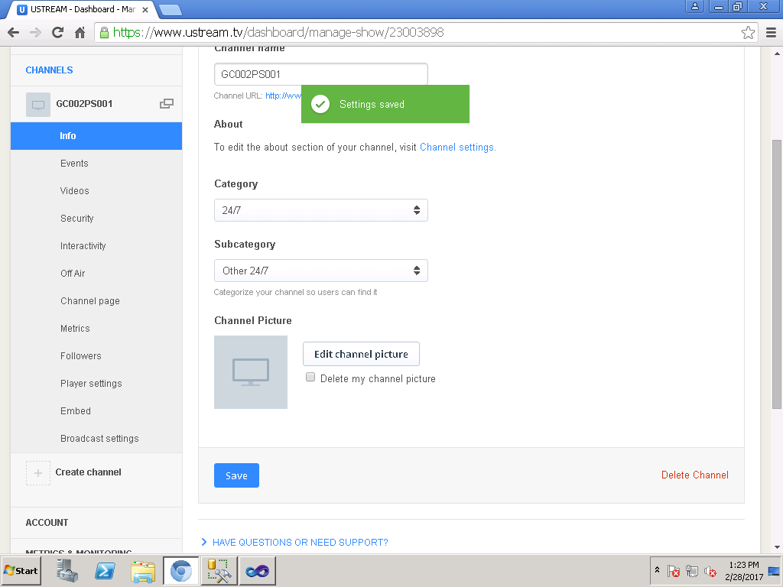
14. Choose Other 24/7 Option under Subcategory
15. Click Save Button
16. Copy URL Link and Paste it in the bellow format
17. Please Provide us Information required for viewing purpose of webcasting in the format described Below :-
AC No. | Part No. | Email ID | Password | Channel Name | Link
Note :- A) Please Create Channel Name as AC046P001(AC046 is for Assembly constituency No.P001 is
for Part No. )

